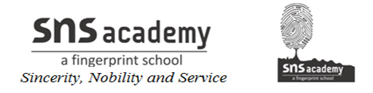
ANNUAL PLAN-2019-2020
GRADE: VII-A, B SUBJECT: SOCIAL SCIENCE
MONTH | UNIT/TOPIC
JUNE | HIS:THE MEDIEVAL WORLD  GEO:OUR ENVIRONMENT  SOCIAL:DEMOCRACY
JULY | HIS: THE REGIONAL KINGDOM  GEO-INSIDE OUR EARTH  THE CHANGING EARTH  SOCIAL:PILLARS OF DEMOCRACY
AUGUST | DEMOCRACY IN ACTION  HIS:THE SULTANATE PERIOD  GEO:MAJOR LANDFORMS  SOCIAL: STATE GOVERNMENT
SEPTEMBER | HIS:THE REGIONAL KINGDOM-2  GEO: COMPOSITION AND STRUCTURE OF ATMOSPHERE  SOCIAL: ADVERTISING  MARKET AROUND US
OCTOBER | HIS:THE GREAT MUGHALS  GEO:WEATHER AND CLIMATE  WATER  SOCIAL MEDIA DEMOCRACY
NOVEMBER | HIS: TOWNS, TRADERS AND CRAFTSMAN  GEO:NATURAL VEGETATION AND WILD LIFE  HUMAN ENVIRONMENT  SOCIAL: ROLE OF GENDER
DECEMBER | HIS:TRIBAL COMMUNITIES  RELIGIOUS BELIEF
JANUARY | HIS: THE FLOWERING OF REGIONAL CULTURES  LIFE IN THE TROPICAL AND SUB TROPICAL REGIONS  SOCIAL: INDIA AND DEMOCRACY
FEBRUARY | GEO:LIFE IN THE TEMPERATE GRASSLANDS  LIFE IN THE DESERT  SOCIAL: POLITICAL FORMATIONS IN THE 18TH CENTURY

Signature of the teacher Signature of the HOD

